Copyright Application – Author’s Details
Author 1
Full Name (Last Name, First Name, Middle Name) | Javier, Kynth Ignacio
Date of Birth (yyyy-mm-dd) | 1999-10 -29
Civil Status (Single, Married, Widow, Divorced, Separated) | Single
Sex (Male, Female) | Male
Address (Street No., Village, Subdivision, Barangay) | House #5, Espino Subdivision, Dumoy , Davao City
City/Municipality | Davao City
Contact Number | +639155169263
Email Address | javierkynth@gmail.com
Copy of Government ID with 3 specimen signatures  (if no Govt. ID, use your UM Student ID) | Attach as a separate page

Author 2
Full Name (Last Name, First Name, Middle Name) | Misa, Tom Andre Badilles
Date of Birth (yyyy-mm-dd) | 2000-11-28
Civil Status (Single, Married, Widow, Divorced, Separated) | Single
Sex (Male, Female) | Male
Address (Street No., Village, Subdivision, Barangay) | Blk 4 Lot 20 Pacific Ocean St, Bago Aplaya
City/Municipality | Davao City
Contact Number | +639776909401
Email Address | tomandremisa@gmail.com
Copy of Government ID with 3 specimen signatures  (if no Govt. ID, use your UM Student ID) | Attach as a separate page

Author 3
Full Name (Last Name, First Name, Middle Name) | Rafailes, Christian Jake Eliezer, Bulatao
Date of Birth (yyyy-mm-dd) | 2000-07-01
Civil Status (Single, Married, Widow, Divorced, Separated) | Single
Sex (Male, Female) | Male
Address (Street No., Village, Subdivision, Barangay) | Blk 4 Lot 2 Samantha Homes Catalunan Pequeño
City/Municipality | Davao City
Contact Number | 09203222114
Email Address | rafailescje@gmail.com
Copy of Government ID with 3 specimen signatures  (if no Govt. ID, use your UM Student ID) | Attach as a separate page

Author 1

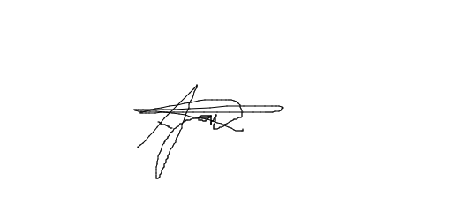

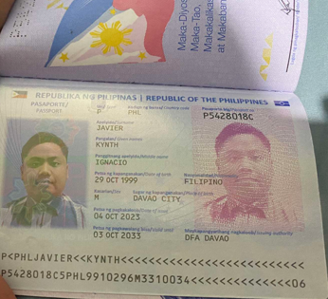ID Here

Author 2

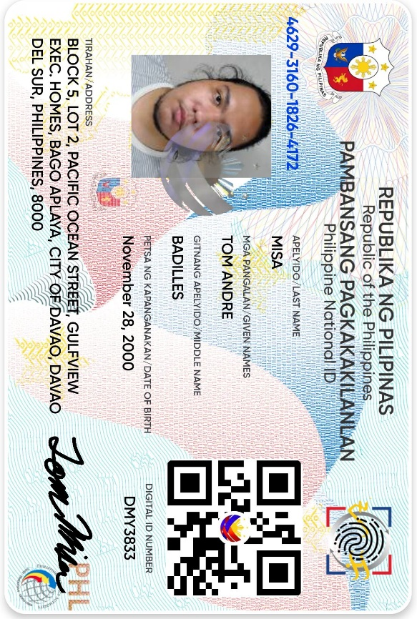

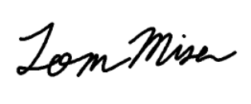





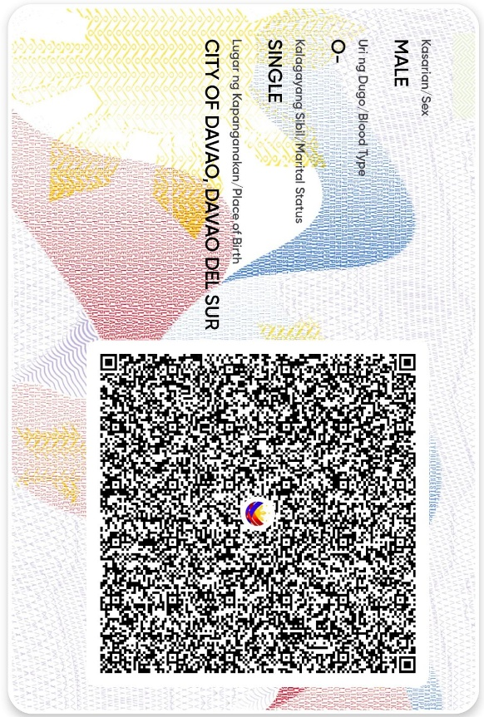

Author 3




